**DMWA LAB Tute -2**

Teghdeep Kapoor

18104050

B12

Q1.

1. Employee.arff saved

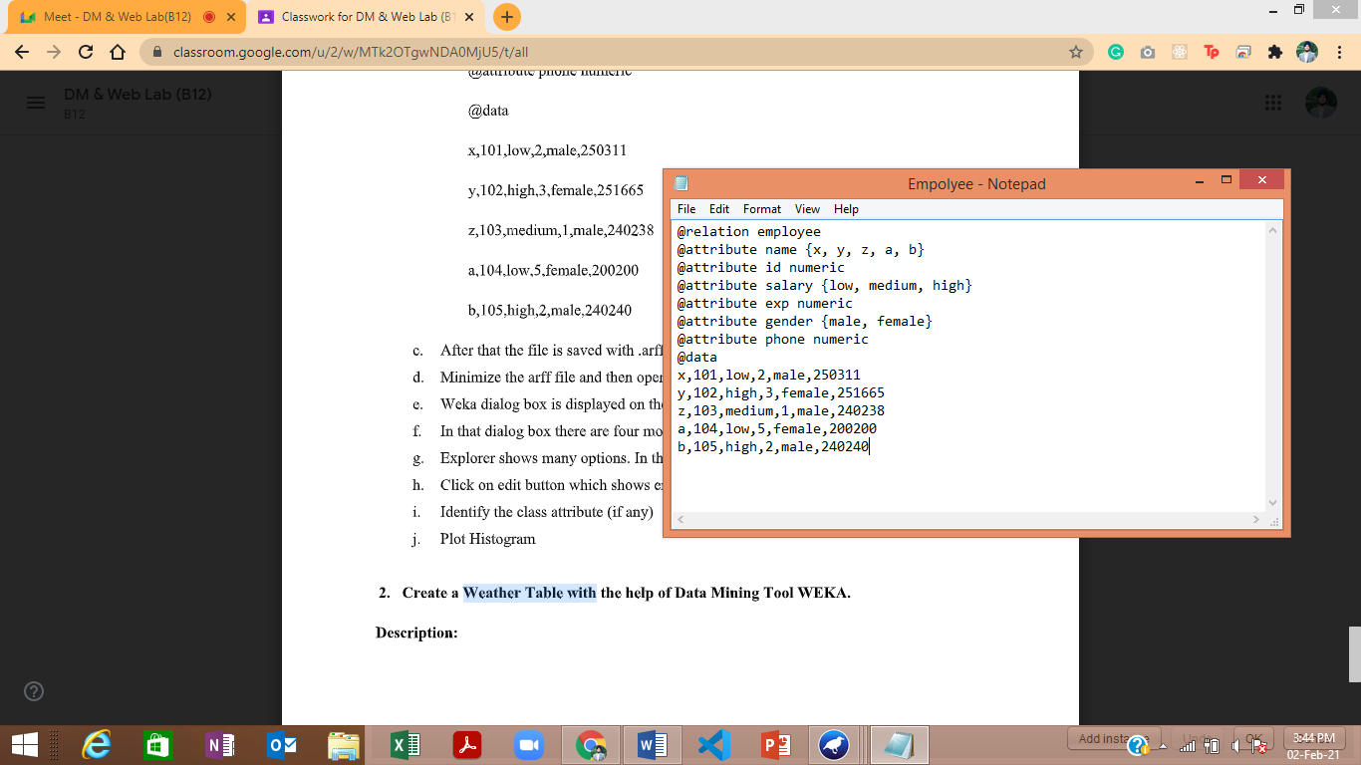

1. Class Attribute – Phone(Numeric) by default

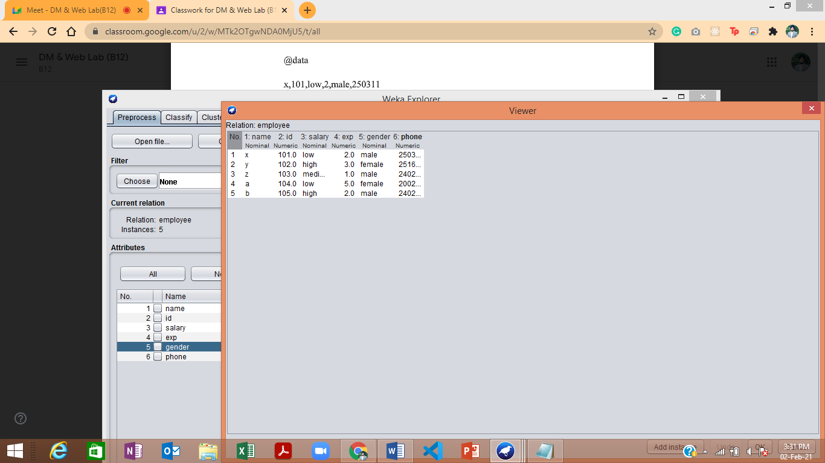

1. Plot Histogram

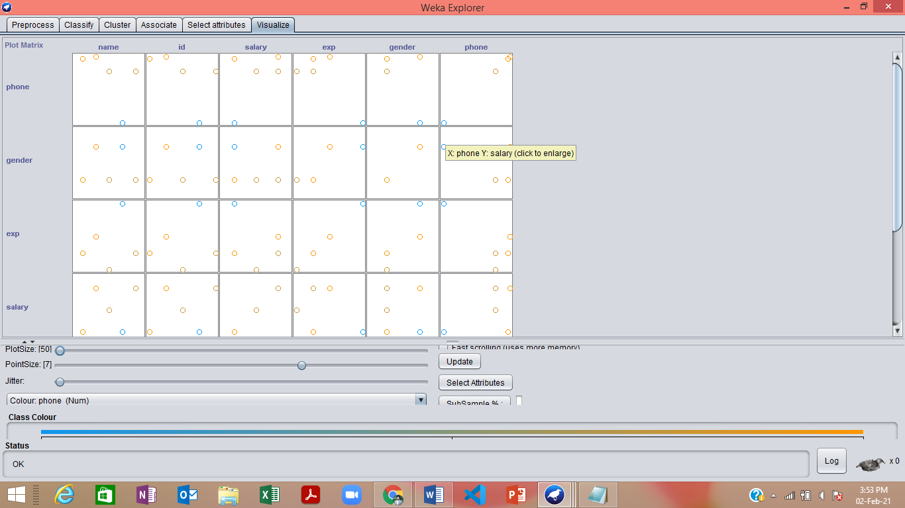

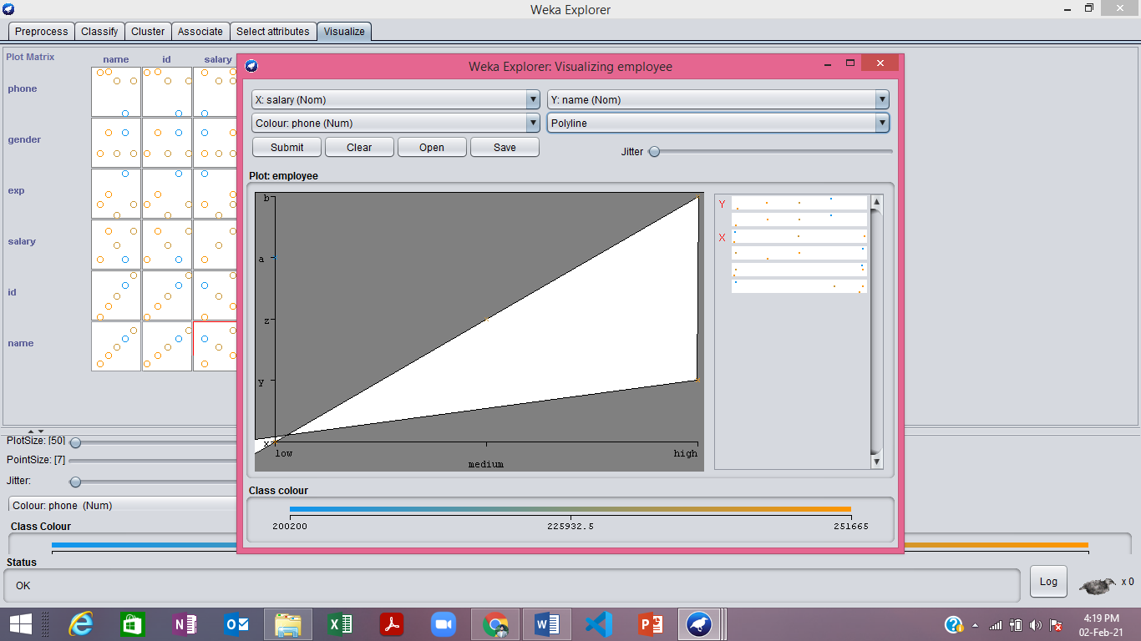

Q2.

1. Earlier class attribute was “play”

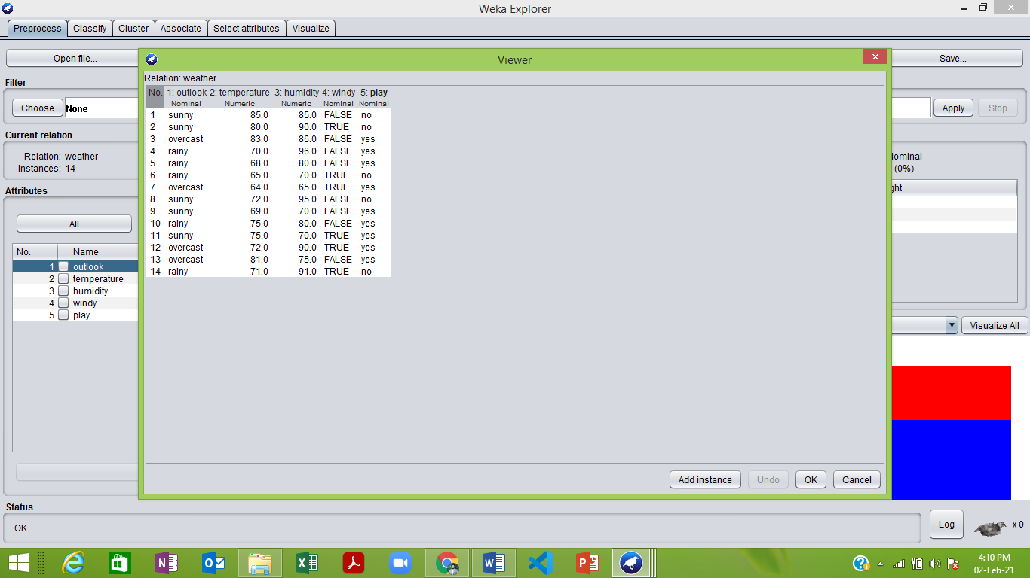

Now, class attribute is “outlook”

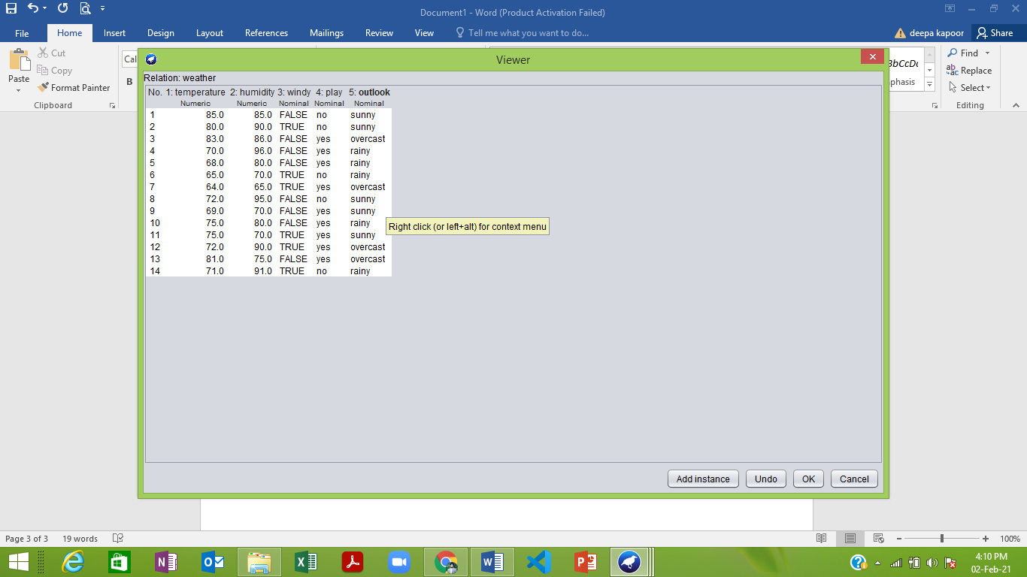

1. Visualize all

